TERMWORK 2

NAME: OMKAR PATIL

USN: 2GI20CS084

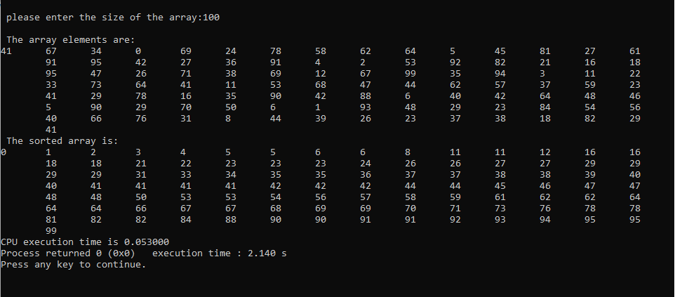

|  |  |
| --- | --- |
| **n** | **t** |
| 100 | 0.053 |
| 200 | 0.656 |
| 300 | 0.985 |
| 400 | 1.066 |
| 500 | 1.4 |